**Show and Tell 3:**

**Viewport: to restrict player’s position in screen;**

1. Creat a Singleton class for viewport, cause viewport only have one instance in game;

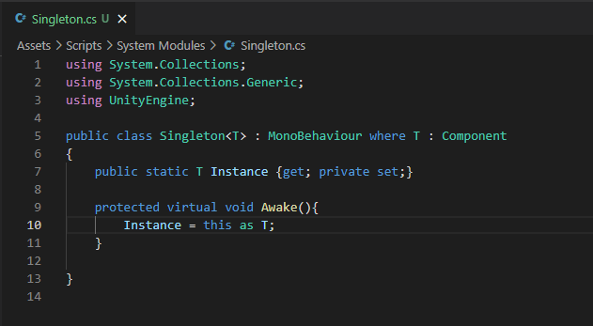

1. Creat a Viewport class and implement Singleton, limit camera in viewport

Add Viewport script to Environment

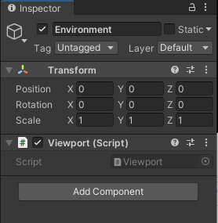

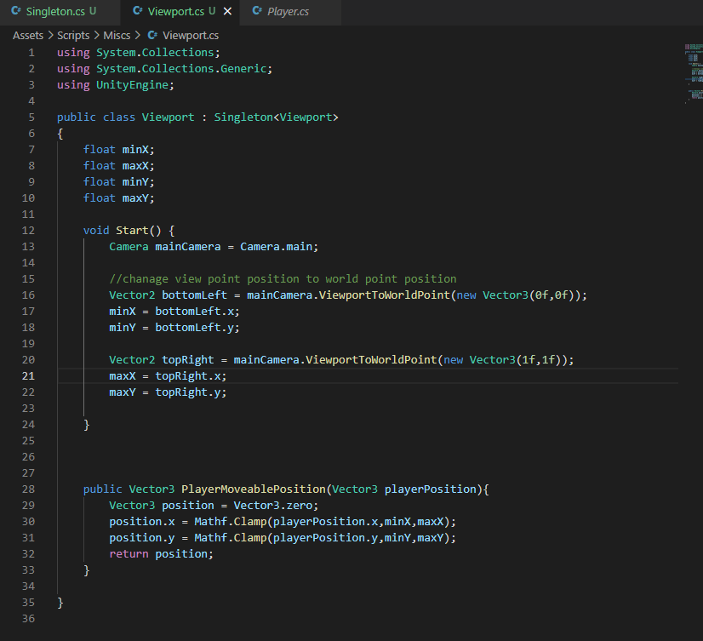

Write a function for player to limit positon

1. Add a Coroutine to update player’s position and limit it by moveable position function, start this coroutine when player move, stop it when player stop move.

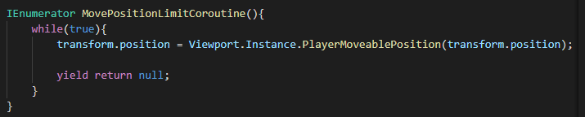

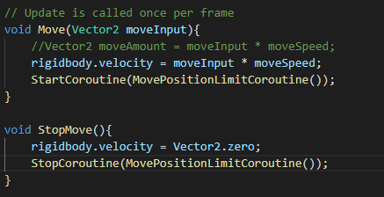

Then the player can be limited in screen

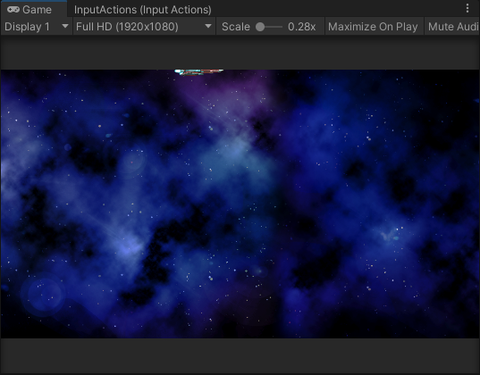

1. Add offset to position make player’s position more accurate

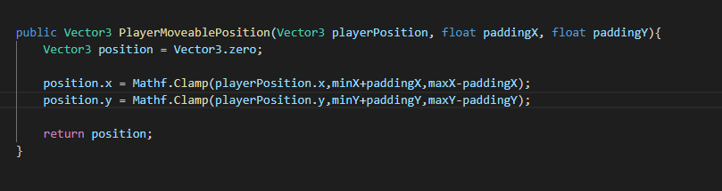

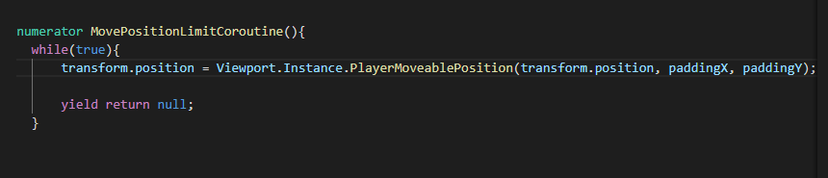

Now player’s position is more accurate

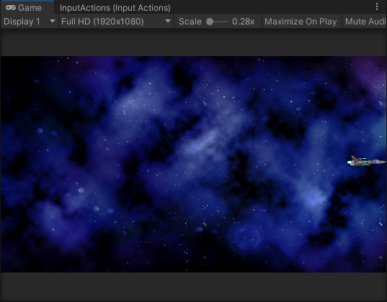

**Movement improvement: make player accelerate and slow down when moving, add rotation**

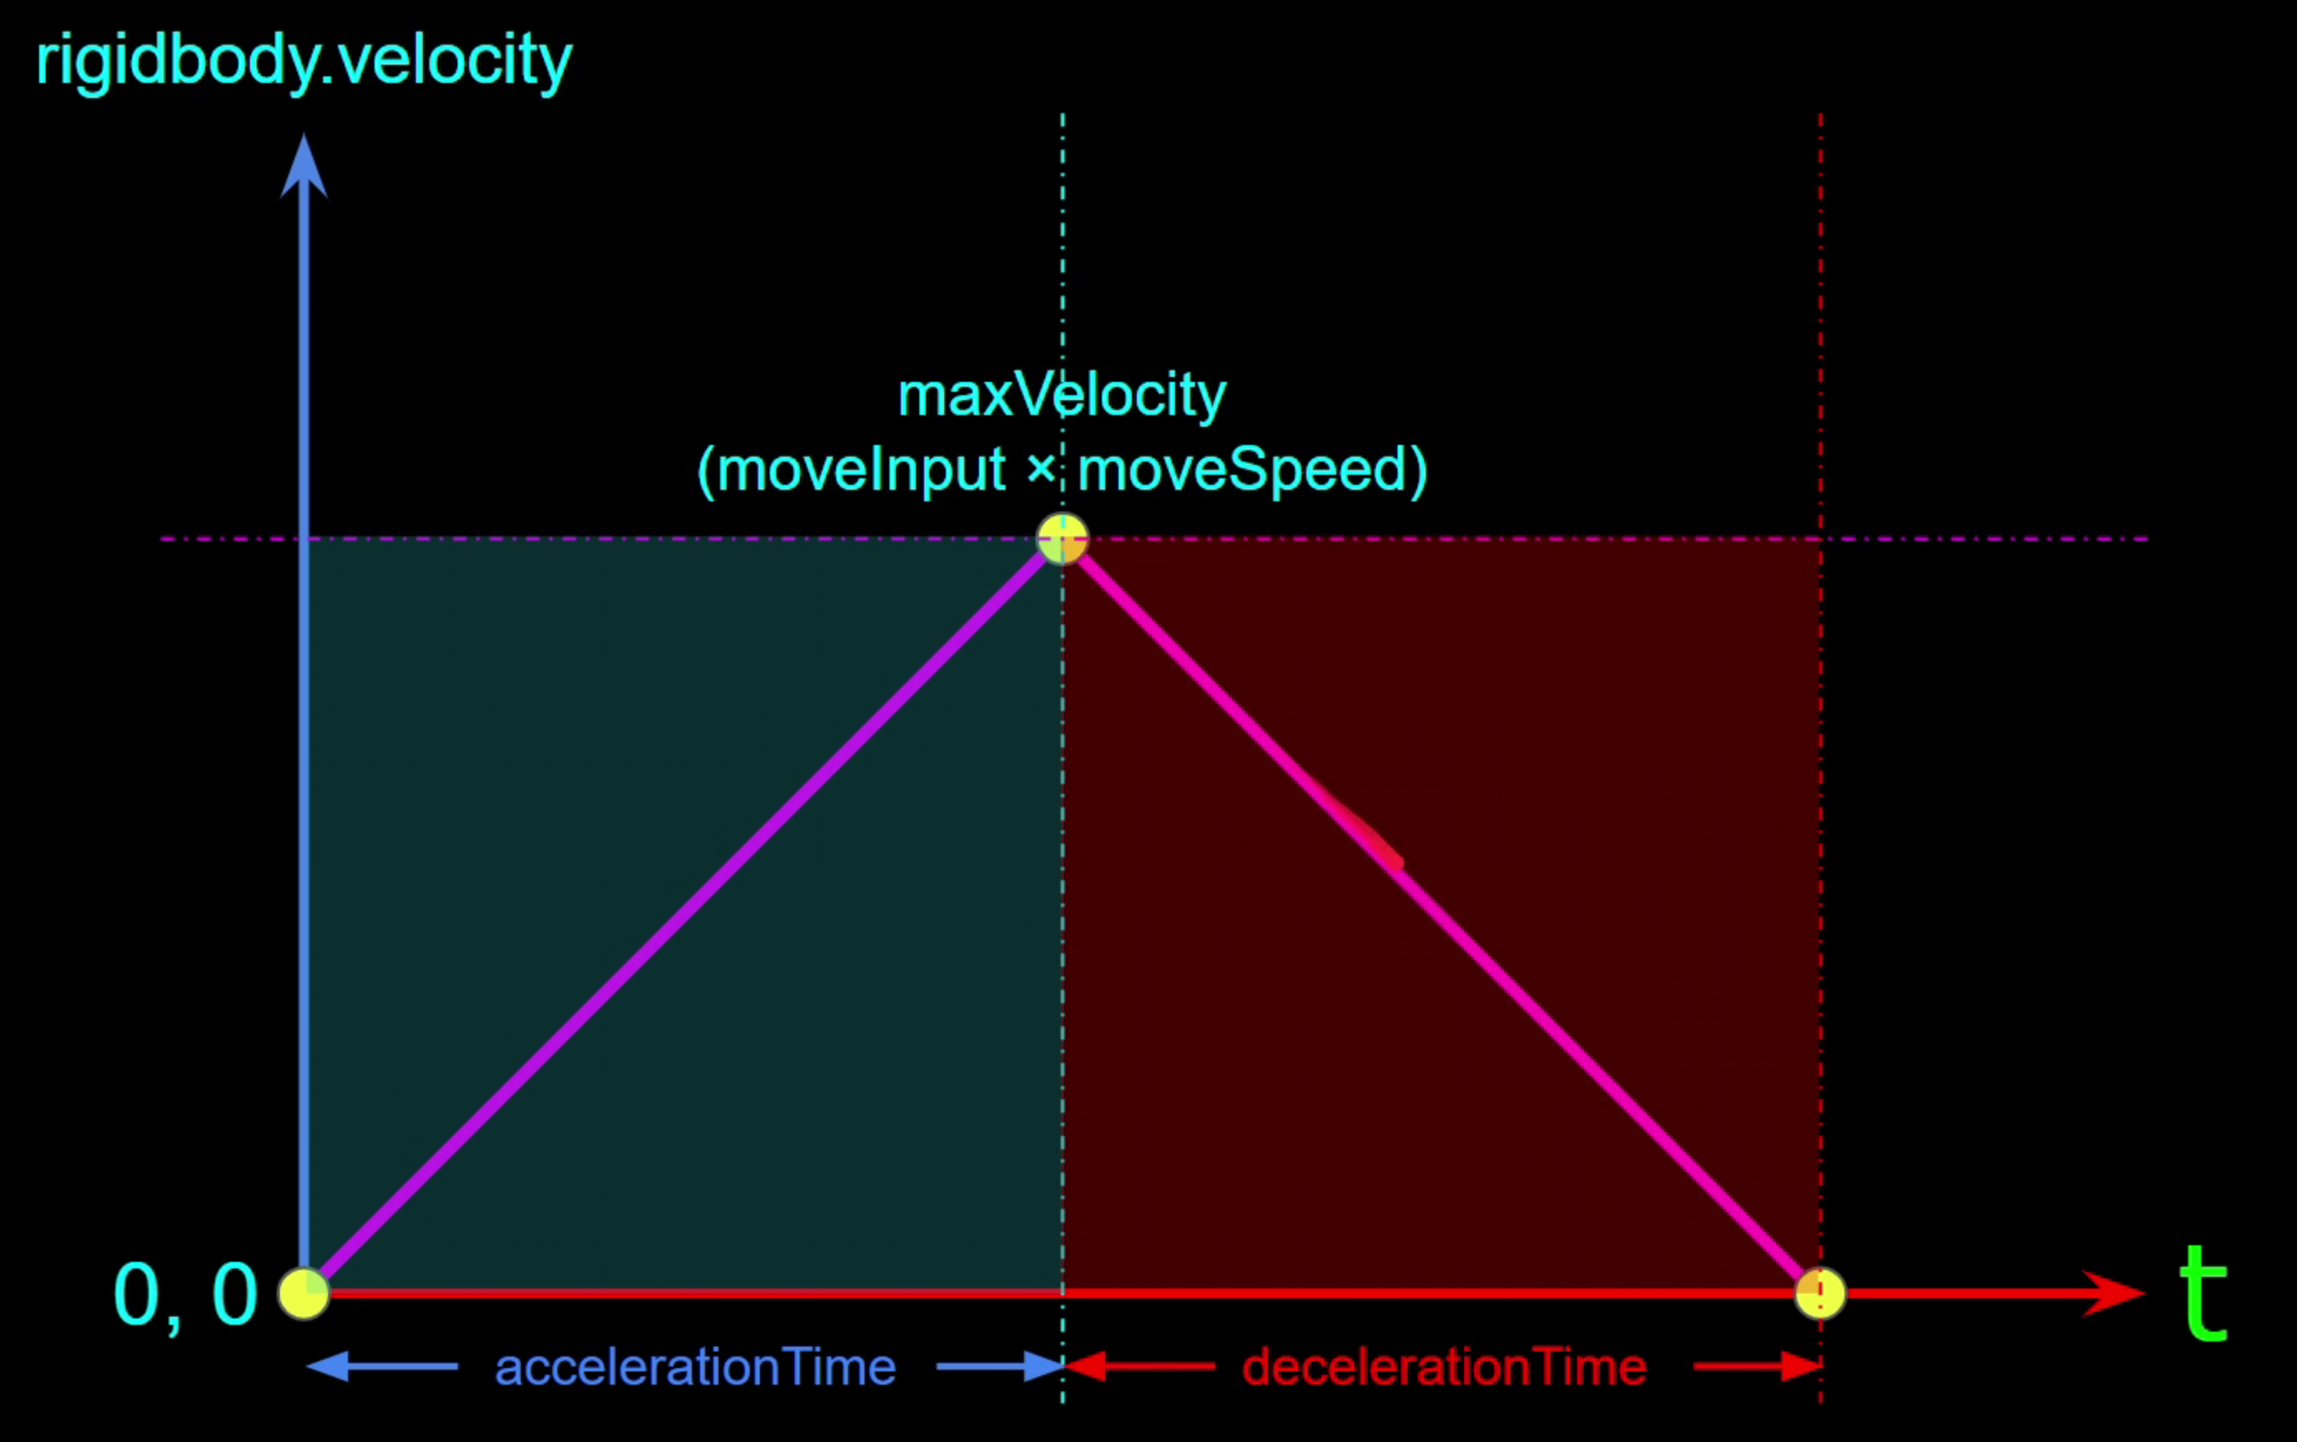

1. Add a coroutine to make speed increase evenly by time

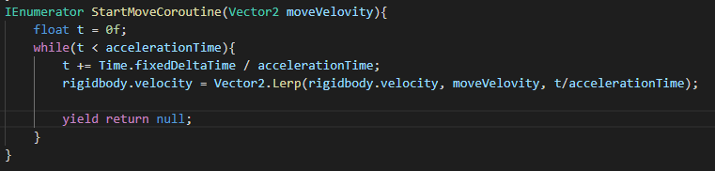

And same thing for decelerate

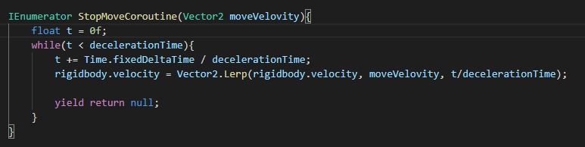

I combined them together

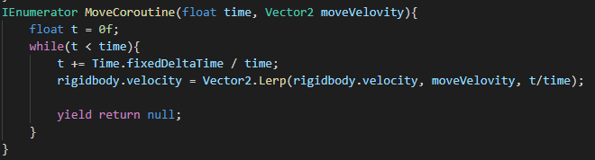

And start/ stop routine when move/stop move

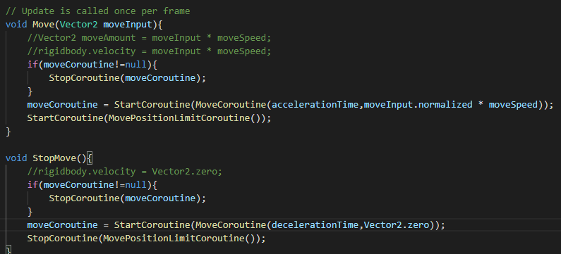

1. Add rotation

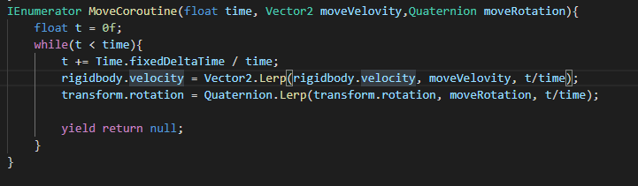

Use an angle and user input to calculate axis

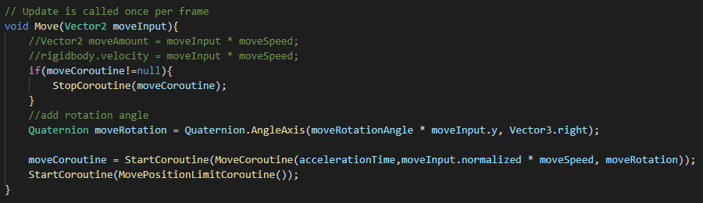

Then the player can rotate

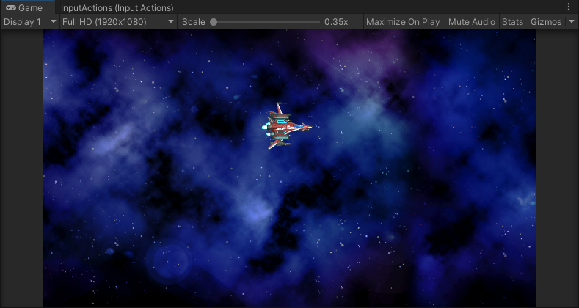

**Post Processing Volume, Bullet**

1. Set camera, enable post processing

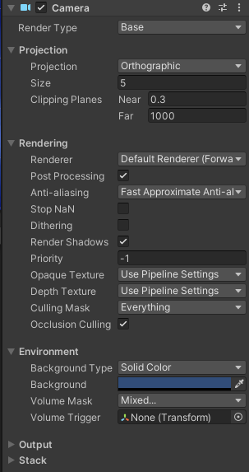

1. Add a bloom post processing

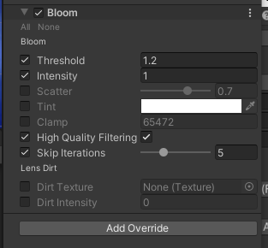

1. Add some other post processing:

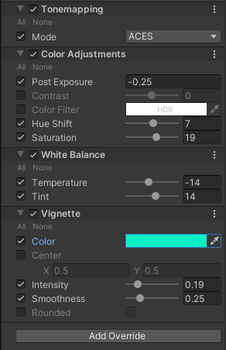

1. After post processing:

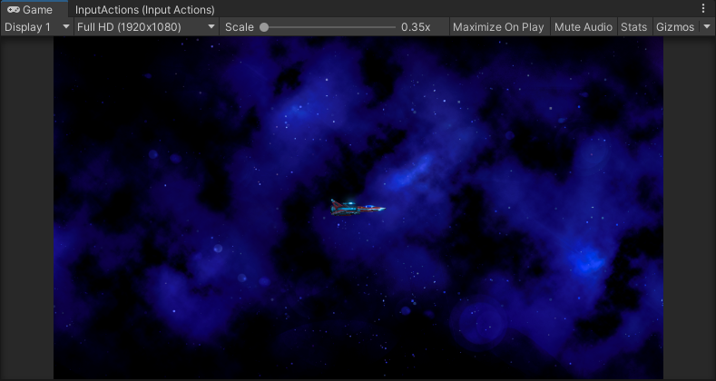

1. Create a projectile object, add bullet mesh and material to it

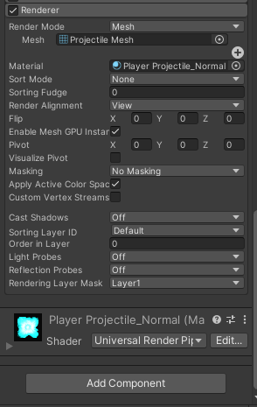

Change the start speed to 0, its speed will control by script

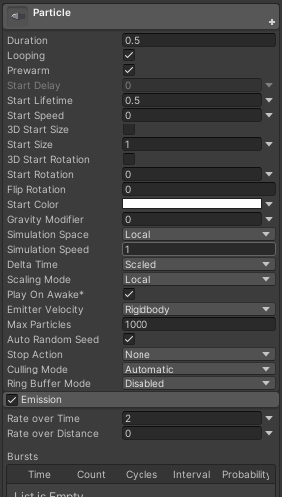

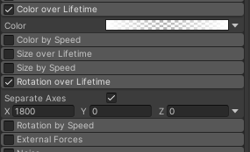

Change color and rotation by time

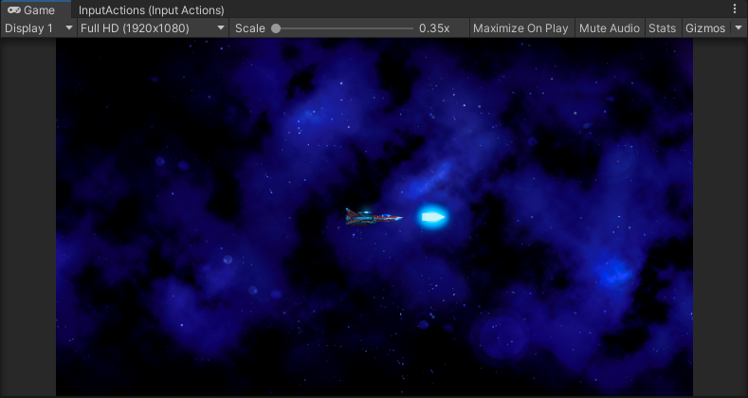

Add a trail to bullet

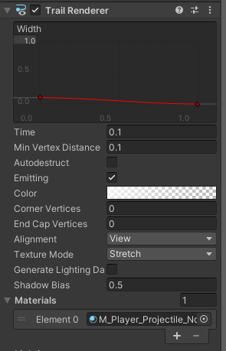

1. Create a projectile class, we have player projectile and enemy projectile, so we need to extend this class for player.

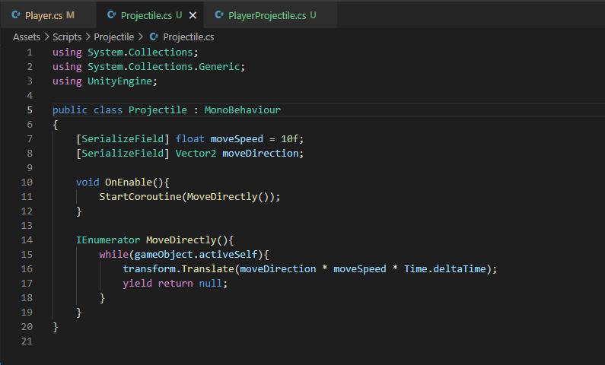

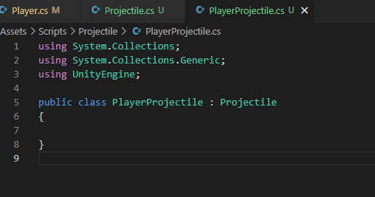

**Bullet shooting**

1. Add Fire to input system

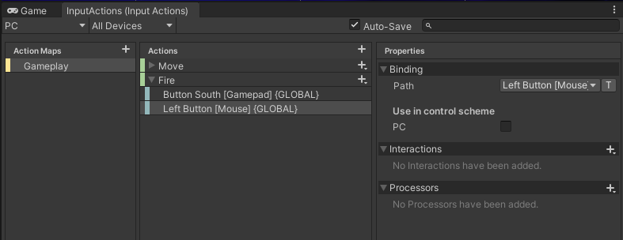

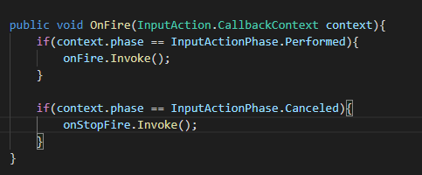

Add Fire and StopFire to OnEnable

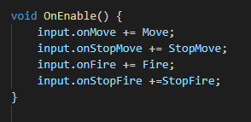

Create projectile object and muzzle object for player

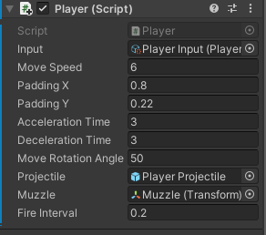

Add another script to auto destroy bullet after a lifttime

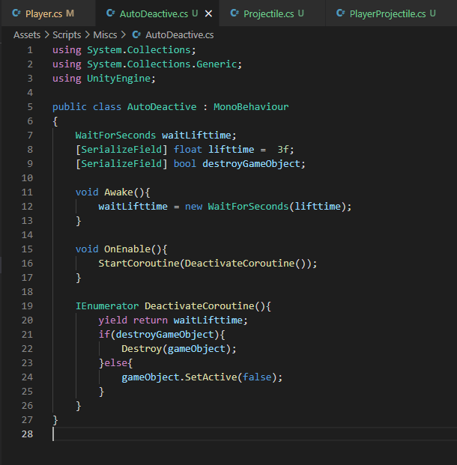

Use a coroutine to keep fire when press keyboard

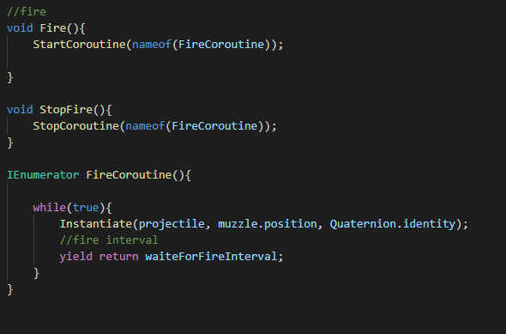

**Object pool**

Why object pool? Performance improvement, less GC

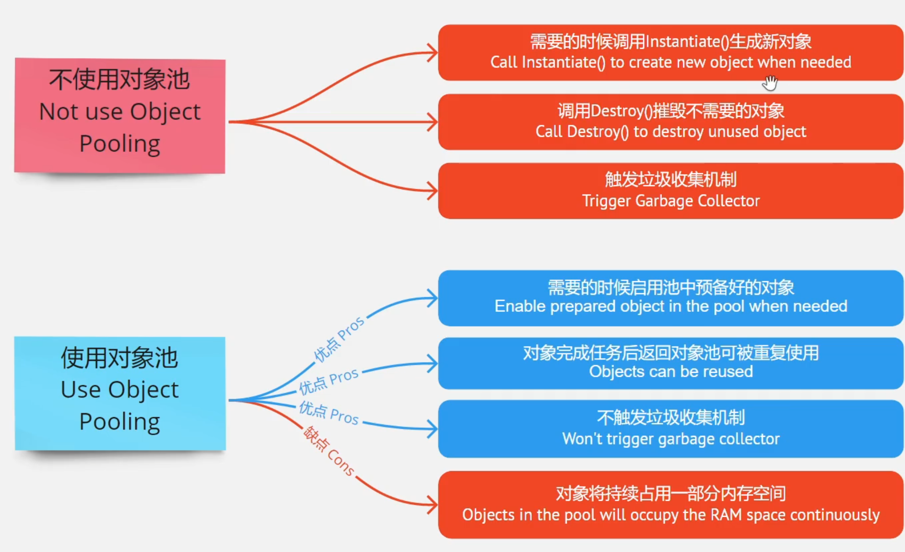

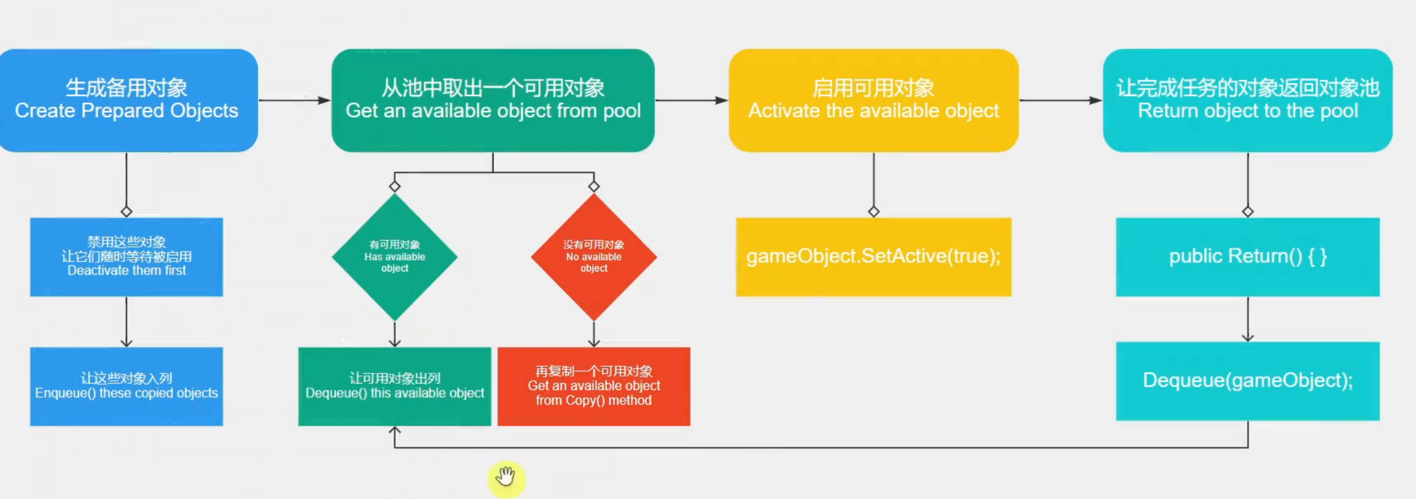

Create a pool class

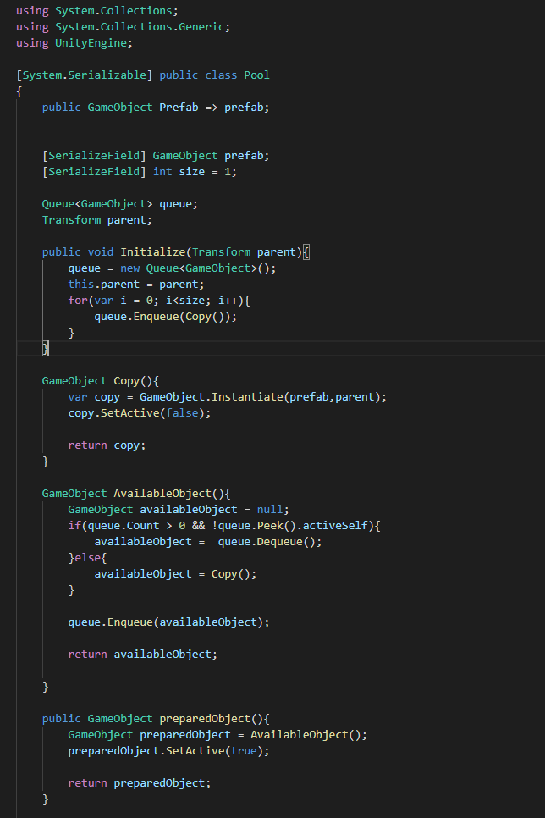

Create a pool manager with a array of pool

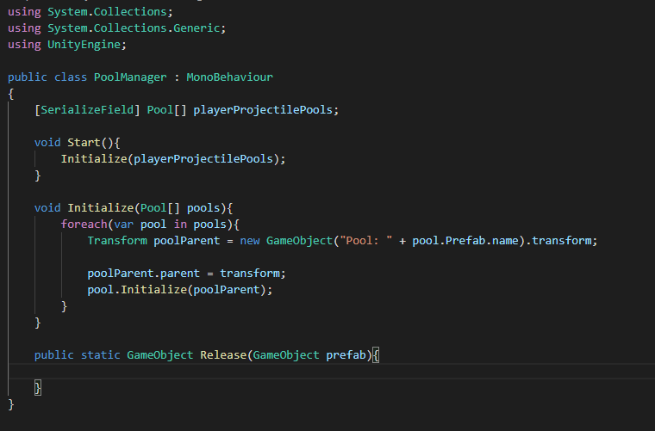

Create dictionary for more prefabs

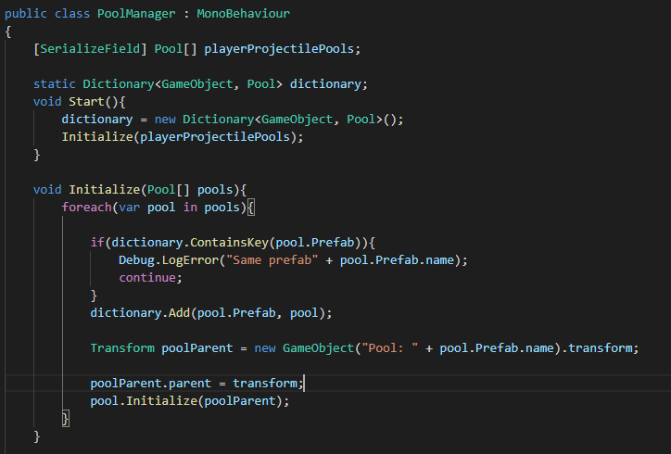

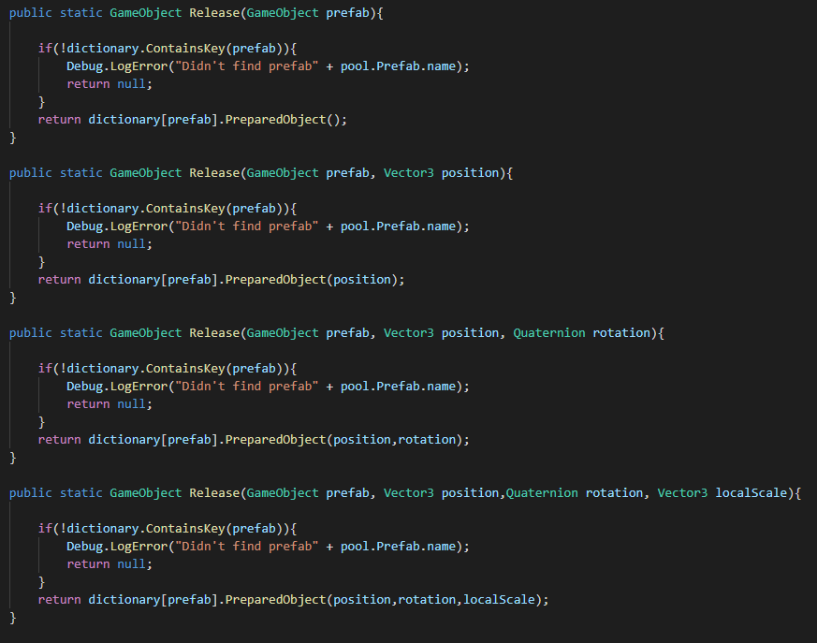

Create weapon power and more muzzle, more projectile

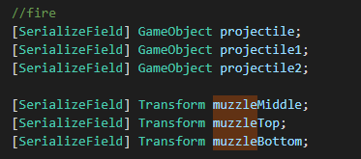

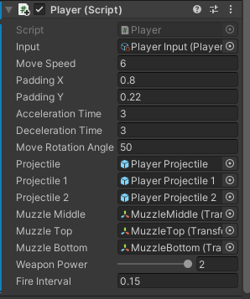

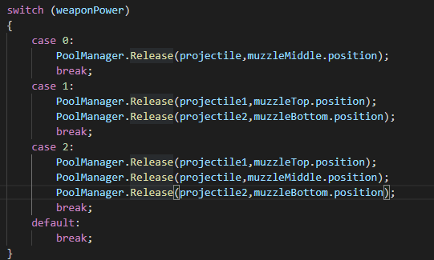

Now player can release more projectile!!

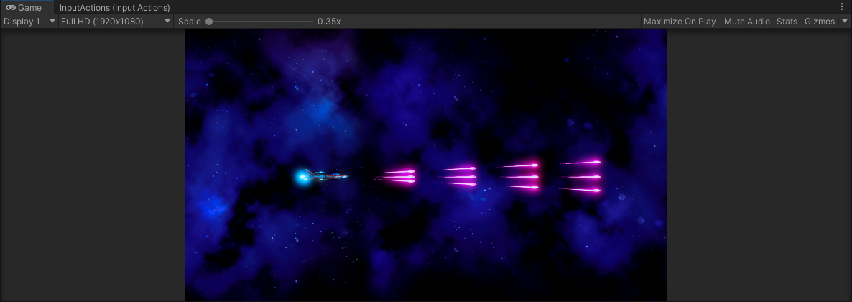

**Enemy**

Create function for enemy born point and moving range in view port

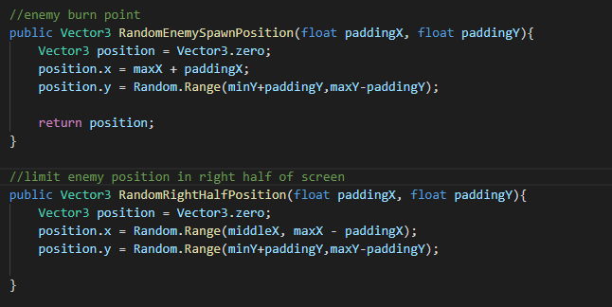

Create a controller for enemy, move function

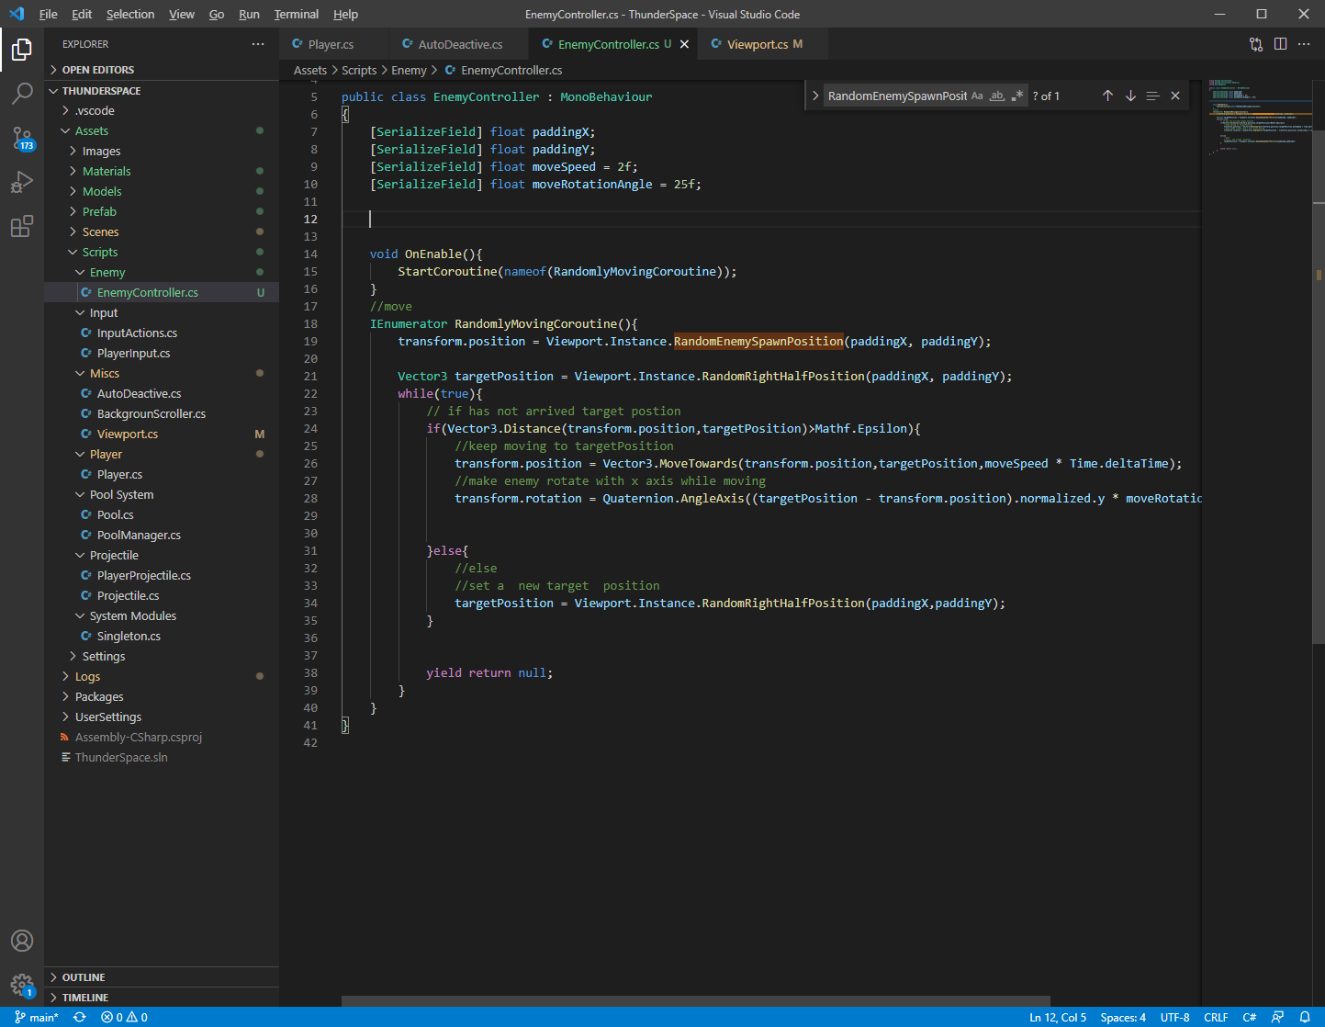

Enemy fire function

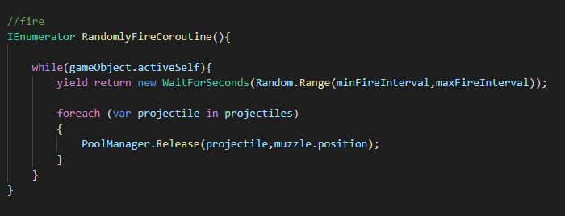

Add enemy projectile

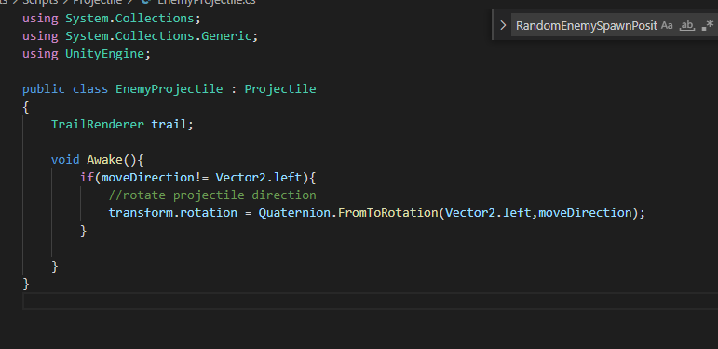

**Health System**

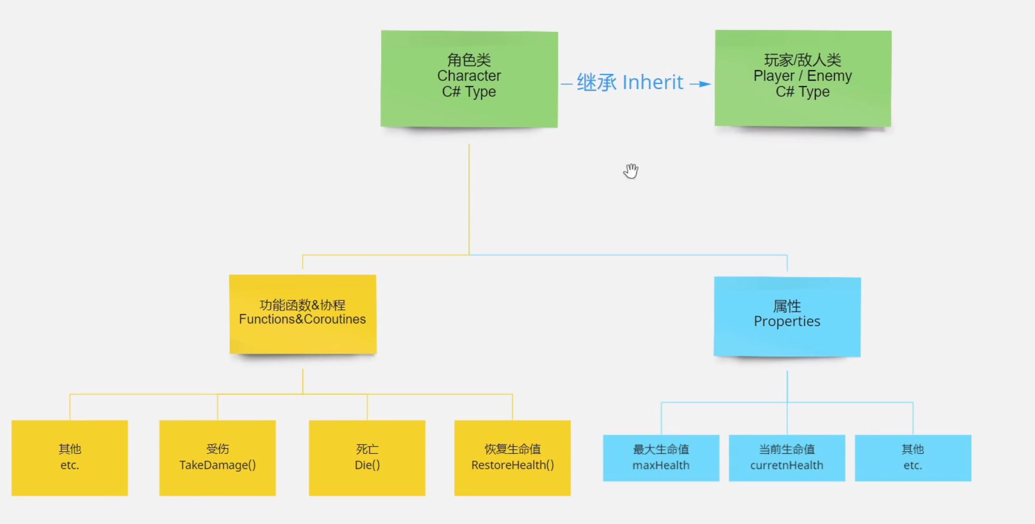

Create a Character class for player and enemy, it has take damage, restore health and die.

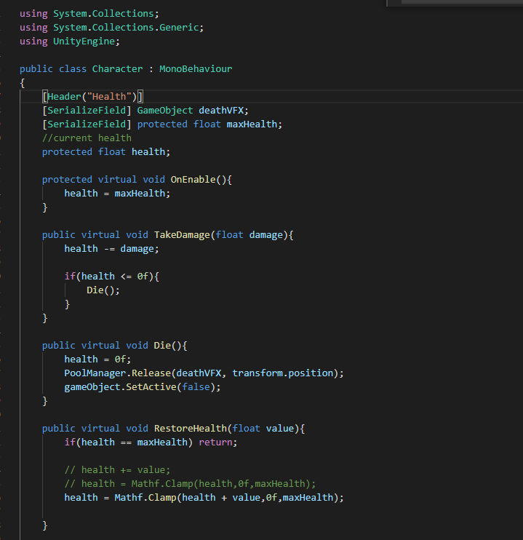Player can take damage by time  
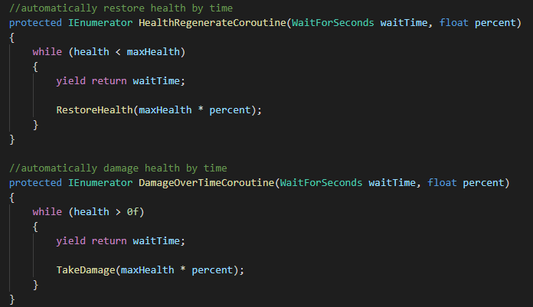

Create different Enemy Projectile

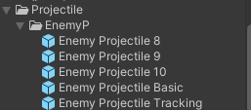

Tracking projectile which can track player

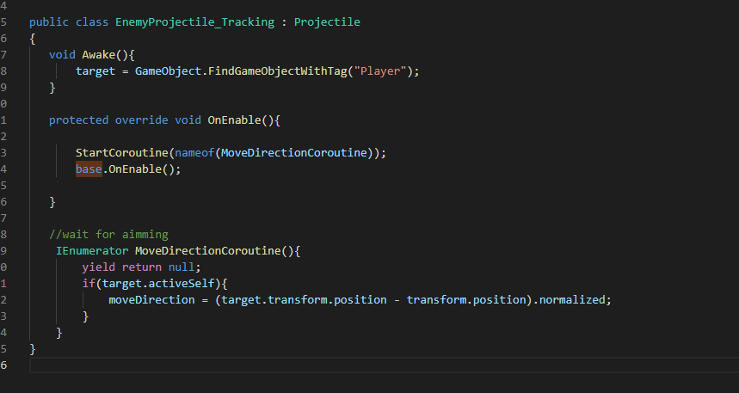

Other projectile has different mesh and directions

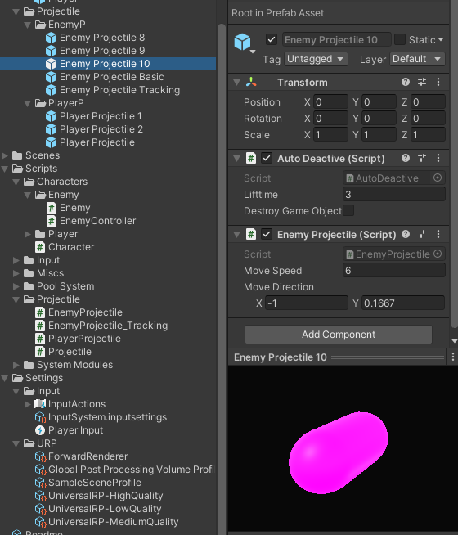

**Projectile hit characters(player and enemy)**

Create different layers for different objects:

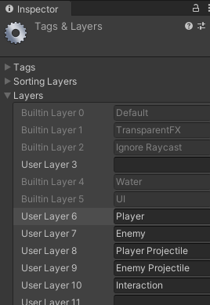

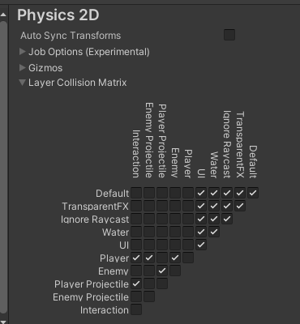

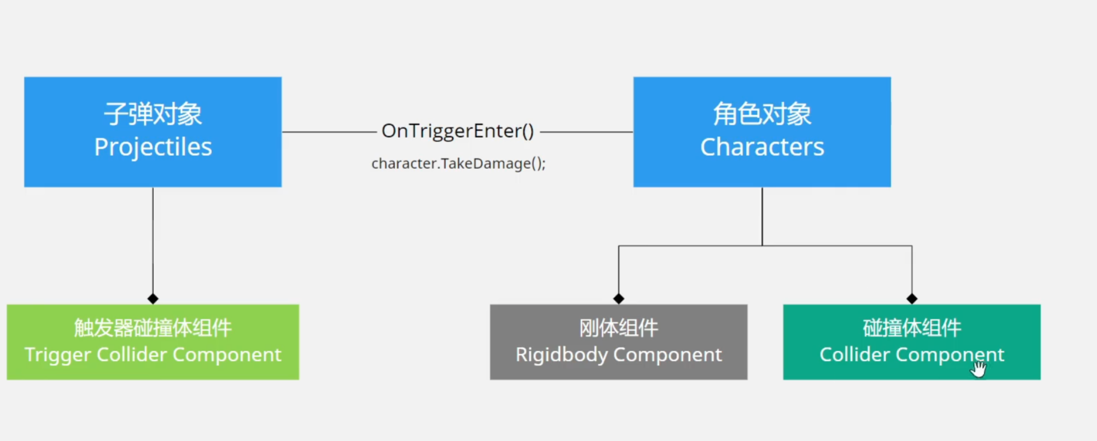

Add Collider to projectiles

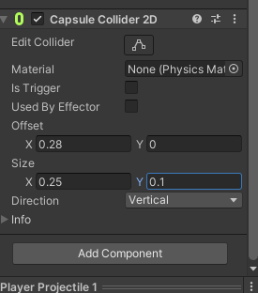

Turn enemy to rigidbody

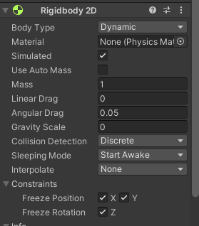

Add Collider 2D to enemy and player

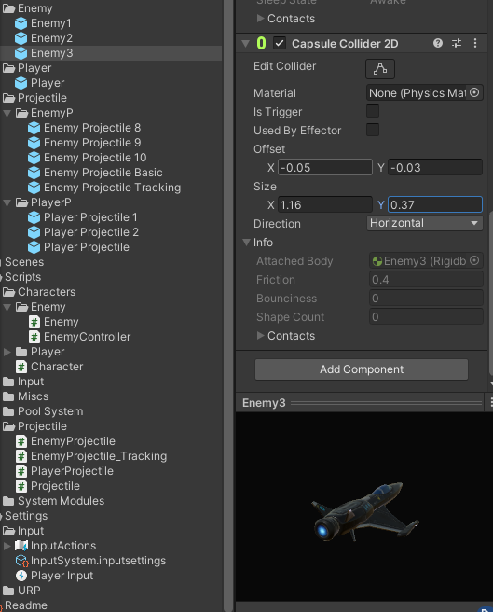

**Health bar**

Create UI canvas for health bar on head

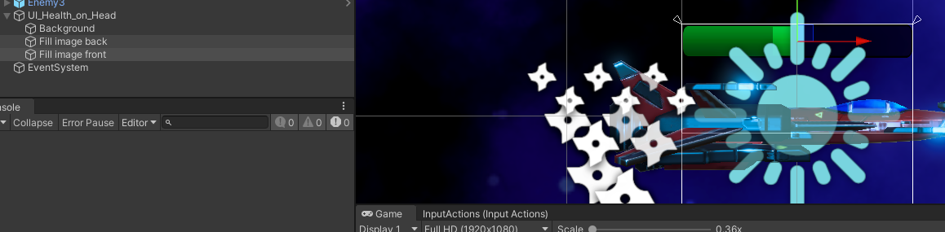

Create stats bar class for player and enemy

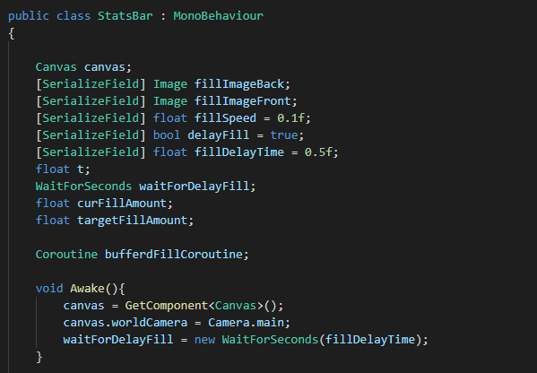

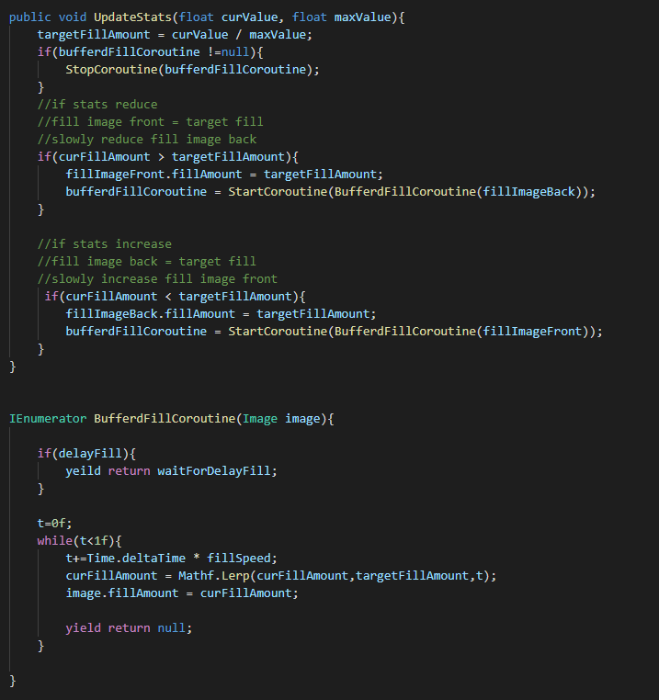

Add health bar to character

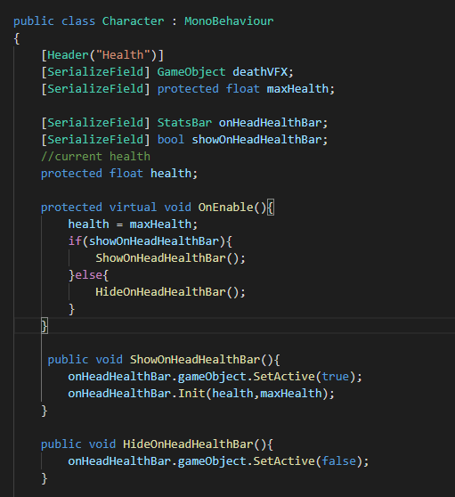

Create HUD Health Bar for player

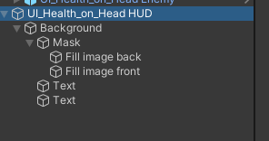

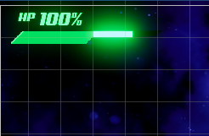

Create a HUD class extended stats bar class to update text in HUD bar

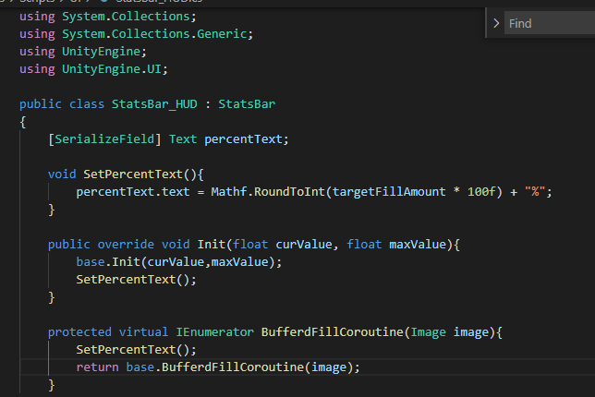

Now player has a cooler Health bar on top left!

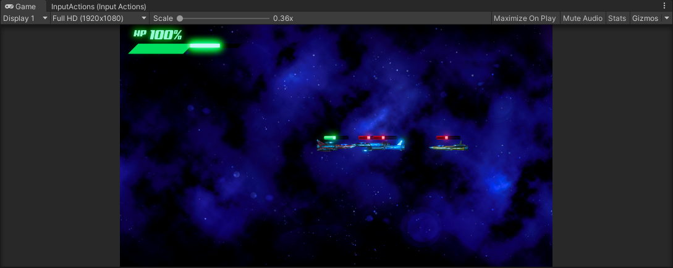

**Enemy Manger**

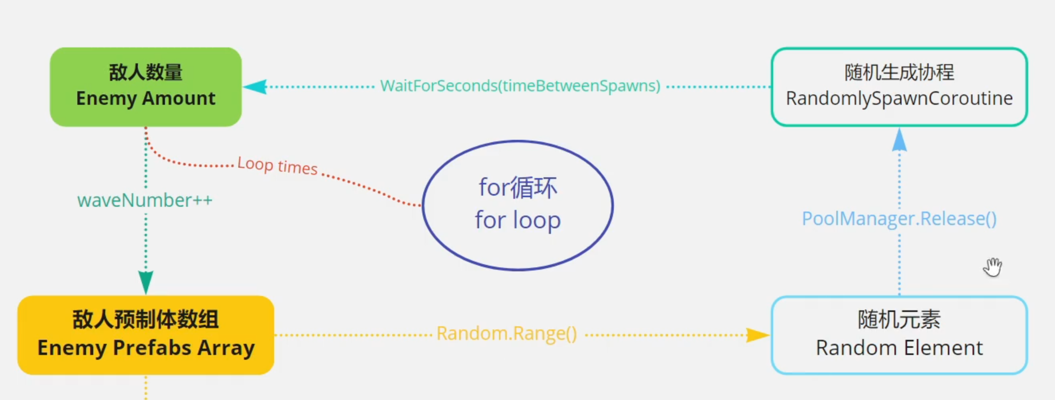

Create Enemy Manager, extend singleton, enemy reborn randomly by time

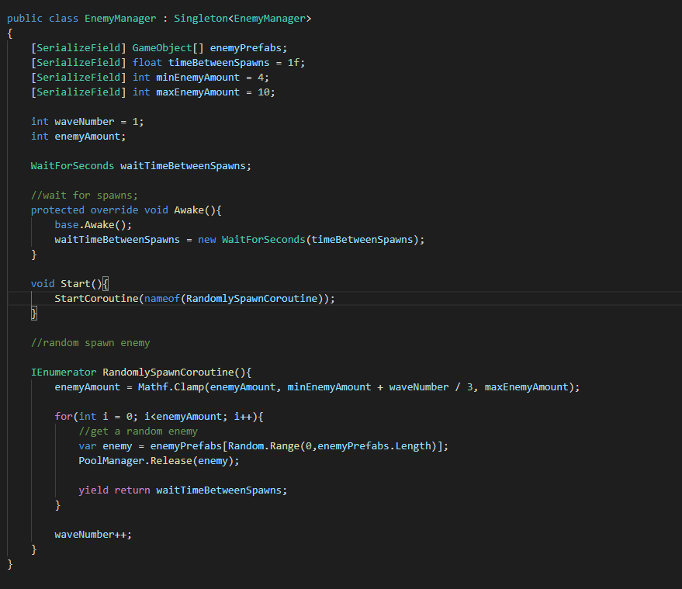

Reborn new enemy when there are no enemy in screen

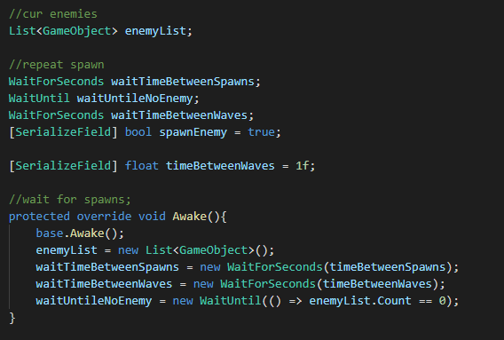

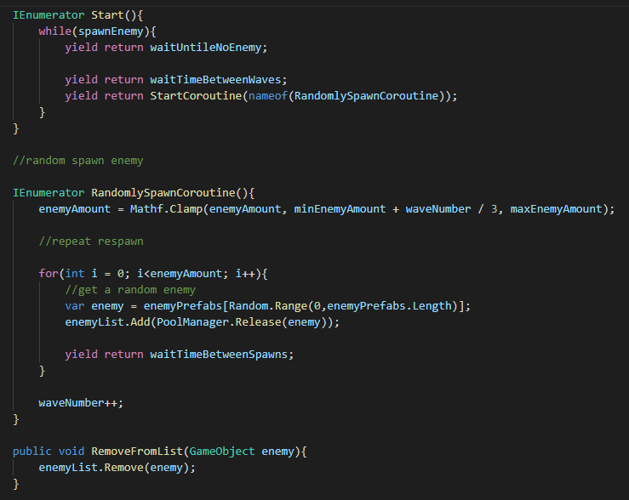

**Wave count UI**

Create a wave UI game object

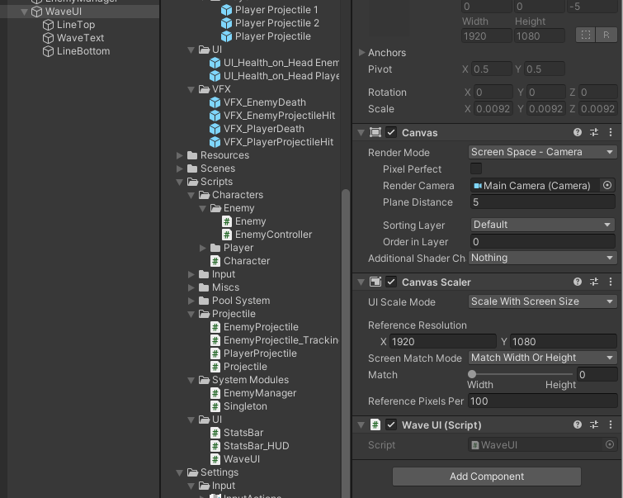

Add a script to get wave number

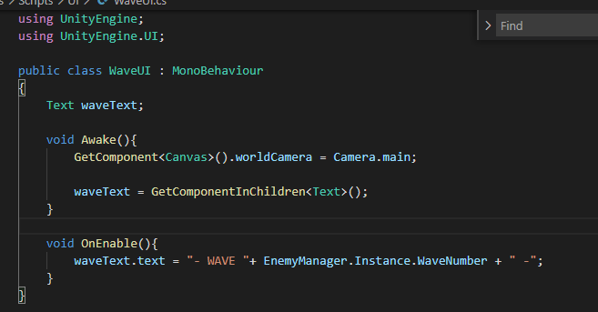

Create animation for wave UI

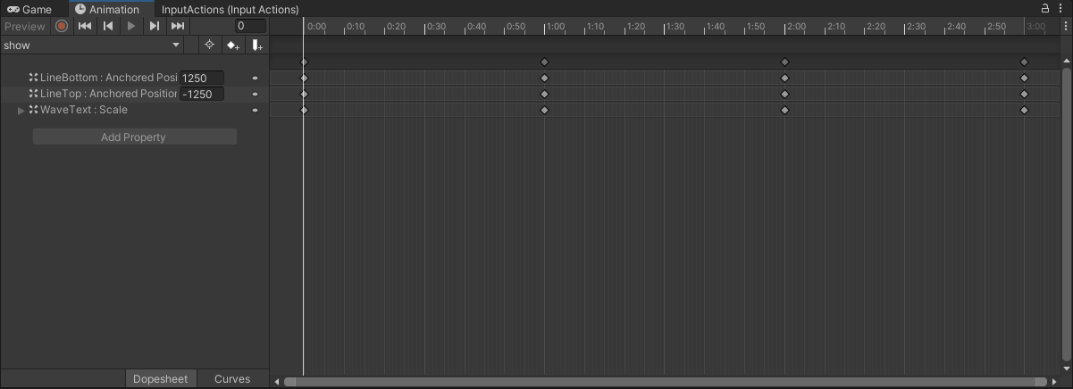

**SFX and Music**

Add a Audio manager to manage audios

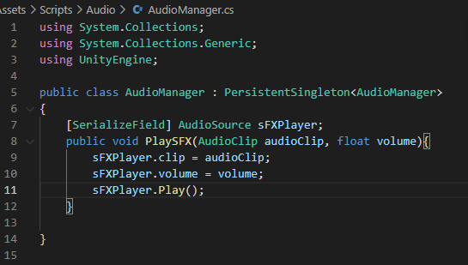

Add SFX for player, character, enemy and projectile

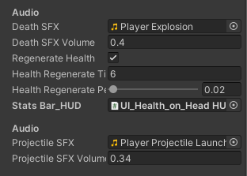

**Simple Main Menu**

Add a new scene called Main Menu

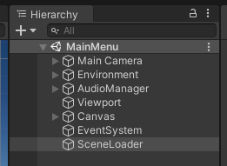

Add a button to it

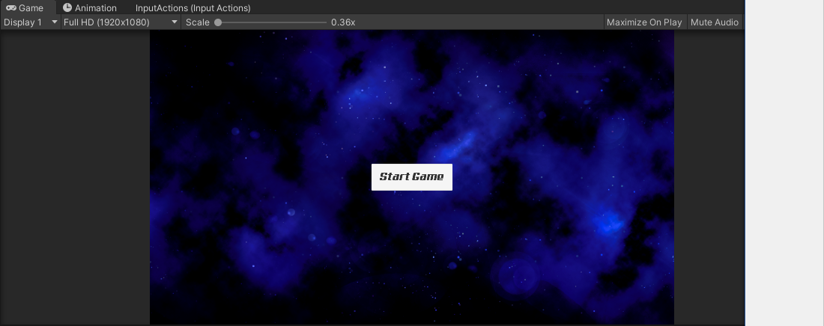

Create a sceneloader script

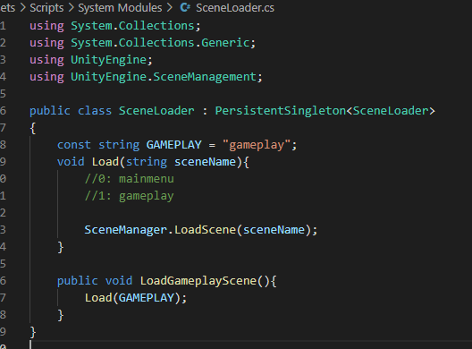

Add on click event to button

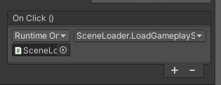

**Score System**

Add a score UI

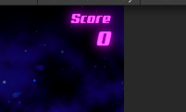

Add a scoremanager to manage score

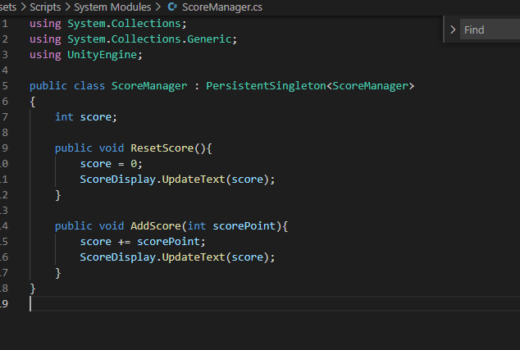

Add a script to update ui

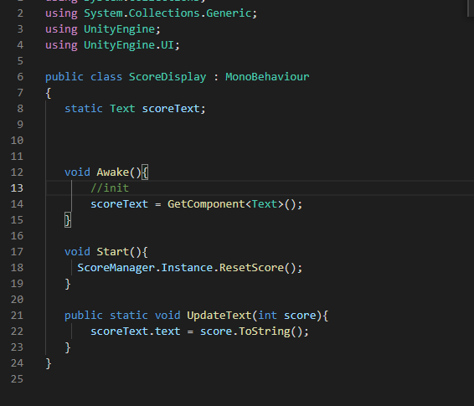

Actively increase score

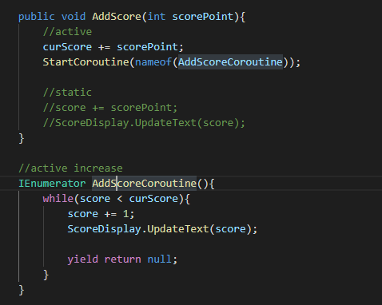

**Pause menu**

Add a pause menu UI

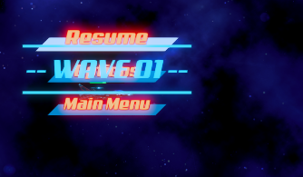

Add animator

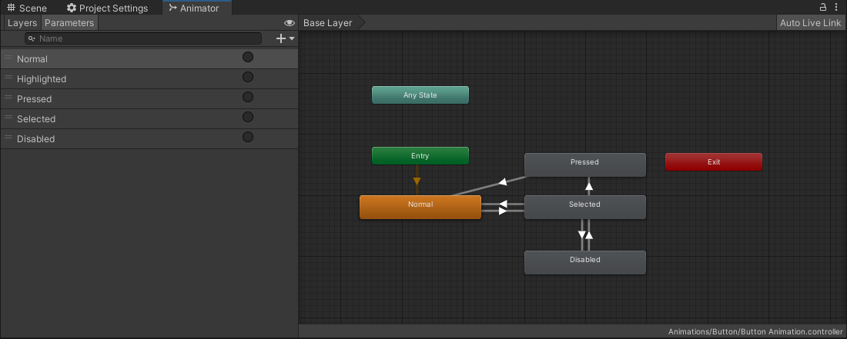

Add input action

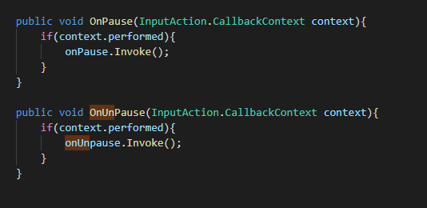

Add a game play controller to controll UI

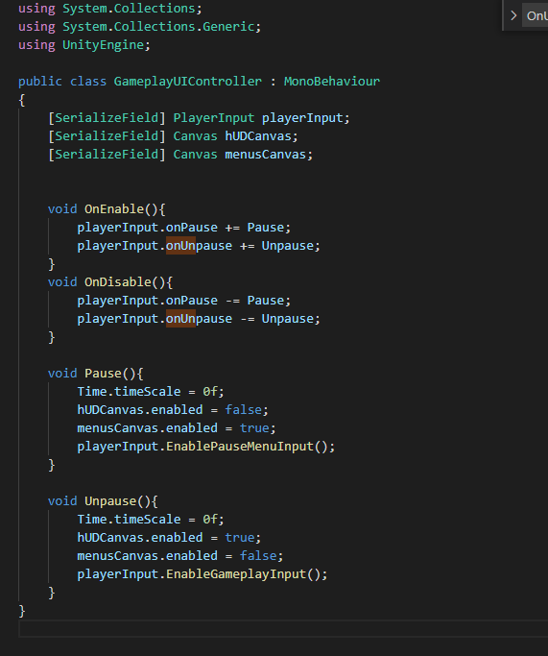

Switch input setting update mode to fix pause

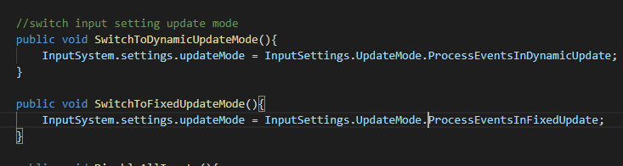

Add function to pause menu button

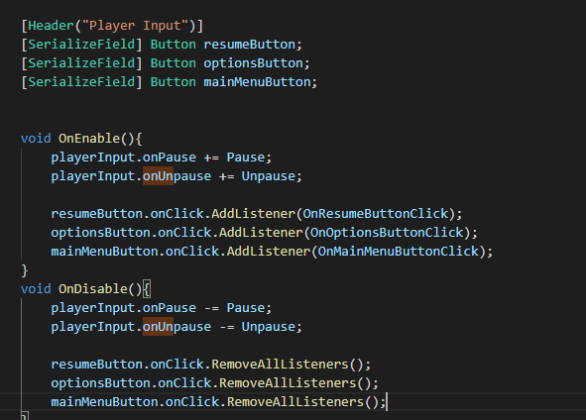

**Game manager**

add a game manager to manage game state

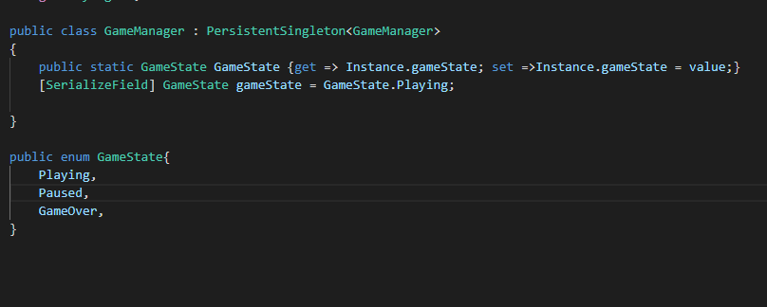

**Main Menu**

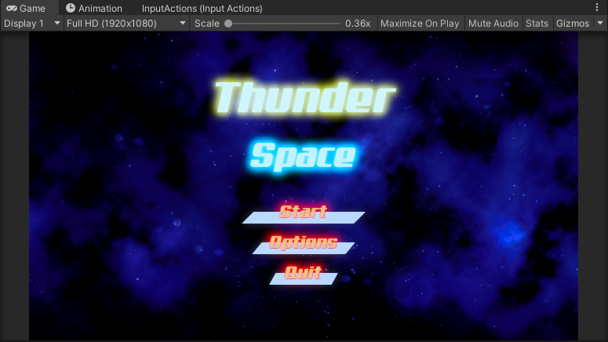

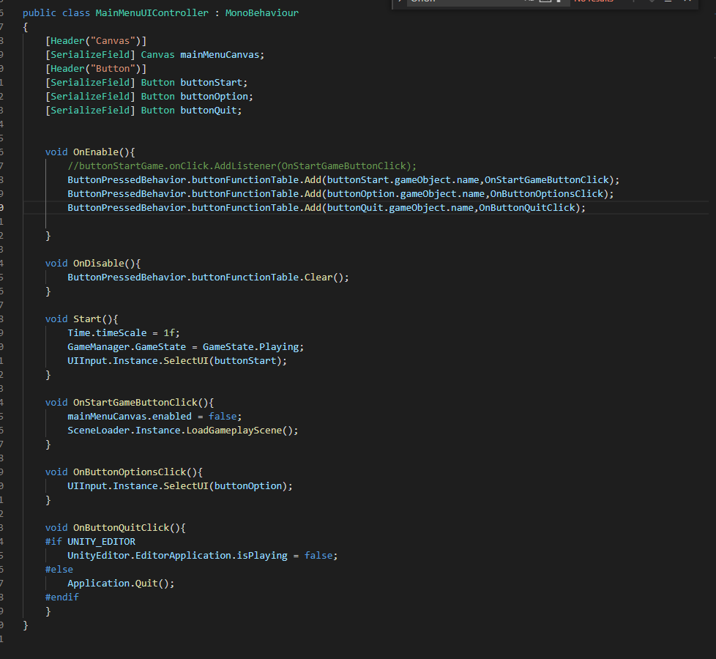

**Game Over Screen**

**Create a Game over UI**

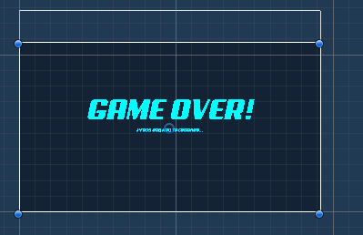

Add a script to control game over

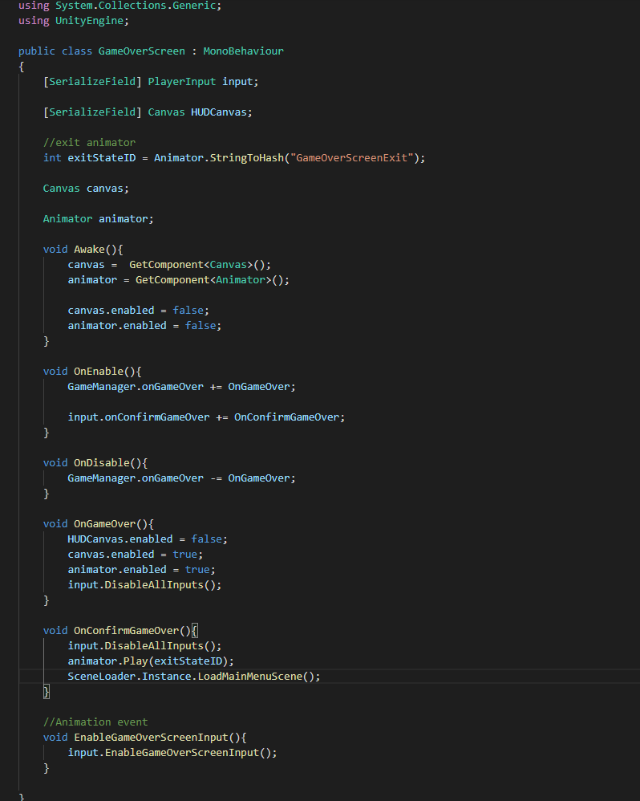

**Show and tell**

Hi everyone, this is a 2D side scroller shooter game, Thunder Space. Our player act as a spaceship fight with other ships in space.

Here is the main menu, our player is a space fighter on the left side, and enemies are on the right side. I did some animation on the button. As you can see when I hover the mouse or select the button, It will have an zooming animation And If I click the button, the background color will change.

When I press start, the game will start. As you can see, the background is scrolling and player can move in screen and can't go out of screen. I use a background scroller script to control this and a Quad to with shader as a rolling background.

The player can use arrows key or WASD to move spaceship. And you can see the spaceship has a accelerate process with rotation and the speed is increasing gradually. I used a coroutine to implement this function and make the movement more real and smooth. Enemies born randomly from right side of screen randomly. I used an Enemy Manager script to control this function. Enemies are restricted to move in the right half of screen and can not go to left side.

It is a survival mode game, in which player try to live longer and get as more score as they can. Player will get score when they destroy enemy ships. Score will display on right top of screen. As you can see the score has a increasing process. I used a coroutine to implement this in score manager script.

Enemy come with waves, There would be a Wave number animation in the center of screen which indicate the current wave. And their amount will increase by more and more waves, this is also controlled by enemy manager. After clear one wave, there will be a next wave with more random amount enemies.

For enemies, there are 3 types of enemies and they shoot different kind of projectile and have different health level and speed. One kind of enemy shoot directly big capsule projectile. And another one shoot 3 projectiles with 3 directions each time. And the last one can shoot the sphere projectile which can track the player's position when ejected.

As we can see, when game is running, there will be so many projectile in the screen in the same time. This means the game program generate a lot of projectile objects in same the time. If I use the original garbage collection function without clean the objects manually, it would be a huge cost for system. So I implement a pool manager to manage projectile in screen with Queues. There queues have sizes and when the objects number is lower than the size, the object will be enqueued and if it is overflow, it will call dequeue to release space automatically.

For the health bar.

Also we can see a health bar of player on the top left of screen. When it goes to 0, the game is over. The health will reduce when player takes damage. And the health will drop to 0 immdiately when crush to enemies. Enemies' health bar is on the top of enemies. Also I added a buffer to health bar which implement by coroutine. it can drop slowly with a buffered time. Also player's health can slower increase by time if health is lower than 100% every few seconds. Which make more change for player to liver longer.

For the pause menu.

When I tap Tab, The game will pause and comes to a pause menu, in which player can resume game or go back to main menu. When go back to main menu, the game will break and lose current record.

When player die, I added an animation to show game is over and press any key, the player will go back to main menu.

This is a game cycle for this time. And I will add more functions later like the pick ups, which can give player scores or more powerful weapon. Also the options menu, to edit BGM or game difficulty. I may add a Boss fight too. So that's all for my project. Thank you for watching!.